Binary Searching of element

#include <iostream>

using namespace std;

int main (int argc, char \*argv[])

{

int Array[10], First, Last, Mid, Special, n;

bool flag = false;

//food

cout << "Enter number of elements: ";

cin >> n;

for (int i = 0; i < n; i++){

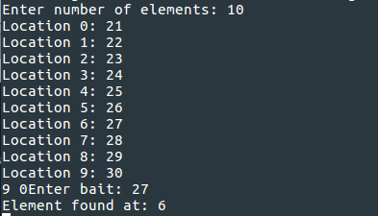 cout << "Location " << i << ": ";

cin >> Array[i];

}

Last = n-1;

First = 0;

cout << Last << " " << First;

cout << "Enter bait: ";

cin >> Special;

//Searching...

while (First <= Last) {

Mid = ((First + Last)/2);

if (Special == Array[Mid]){

cout << "Element found at: " << Mid << endl;

flag = true;

return 0;

}else if (Special > Array[Mid]){

First = Mid + 1;

}else if (Special < Array[Mid]){

Last = Mid - 1;

}

}

if (flag == false) {

cout << "Element not found!";

}

return 0;

}